Driven Racing Oil™ Makes Plans For PRI 2016
Huntersville, NC – The lubrication specialists at Driven Racing Oil™ will be in Indianapolis in mid-December to once again participate in the PRI Trade Show.
Scheduled for December 8 – 10 at the Indiana Convention Center in Indianapolis, the PRI Show will bring together motorsports companies, buyers and media from around the globe. Driven Racing Oil™ will be located in booth no. 419. There the Driven staff will provide information on its wide-ranging line of synthetic and conventional lubricants, plus display its renowned racing products. New AT synthetic automatic transmission fluids, 80W-90 GL4 Gear Oil and Synthetic DCT (Dual Clutch Transmission) Fluid will take center stage. Driven’s XP line of racing oils, BR break-in oils, GO gear oils and cleaners such as Race Wax, Speed Clean and Speed Shield will all be showcased as well.
More information is available at www.pritradeshow.com.
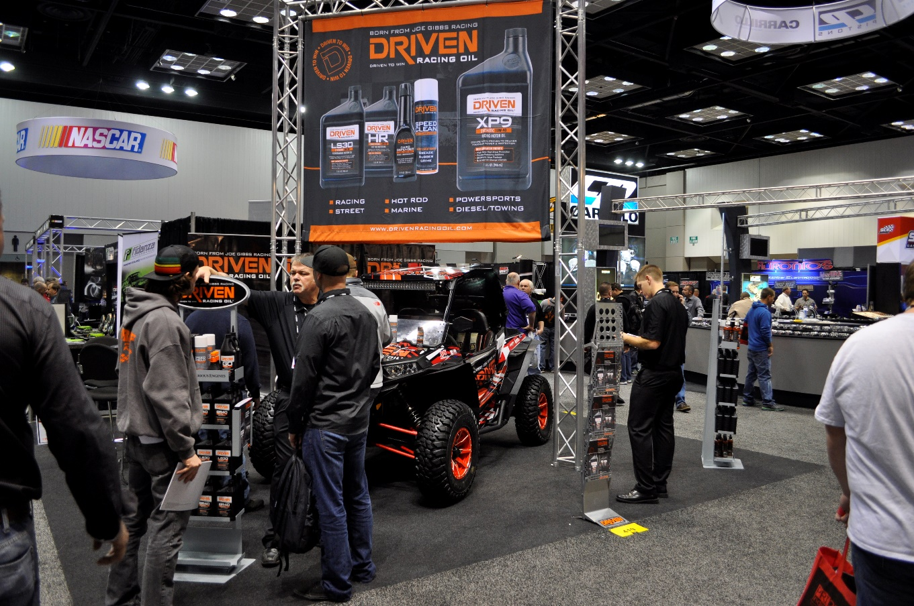

About Driven Racing Oil™
Born from Joe Gibbs Racing, one of the most successful NASCAR teams of the past two decades, Driven Racing Oil™ utilizes cutting-edge lubricant technology and on-track research for maximum performance gains from all of its product offerings. Competition drives innovation, and Joe Gibbs Racing originally developed the Driven brand of oils to advance engine and driveline performance on the racetrack. From full-synthetic race oils to engine break-in oils and cleaners, Driven offers a wide range of race and street products that deliver performance, protection and value.

